

U10-U12 Recreational Rules

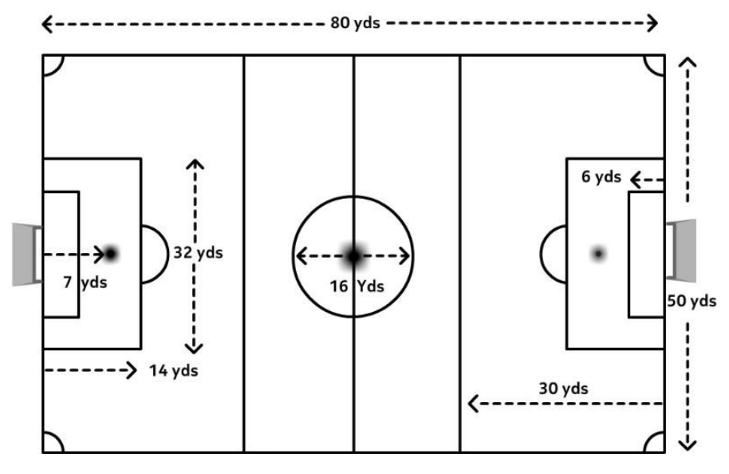

Playing Time: Two 30 Minute Halves
Number of Players: 9 v 9
Including Goalkeepers Minimum: 7 Players

Ball Size: 4
Field Dimensions: 80 yards x 50 yards
Throw— Ins: Yes
Heading: Not Allowed (Per USSF Mandate)
Team Areas : Between the fields, on the opposite side from the spectators

The Field
- Dimensions: The field will be approximately 80 yards long and 50 yards wide, with a center circle with a 10 yard radius.
- Goals: Goals will be 7 ft high and 21 ft wide.
- Goal box: extend 6 yds from the goal line, 6 yds from each goal post
- Penalty Area: extends 4 yards from the goal line, 14 yards from each goal post.
- Build Out Lines: No build-out lines used.

The Ball
A size 4 ball will be provided by the home team.

Players’ Equipment
Uniforms: All Players are required to wear the appropriate jerseys.
The team listed first on the schedule shall be the home team.
Players must not use equipment or wear anything dangerous to themselves or another player (No jewelry of any kind).
Shin guards: Players must wear shin guards covered by long socks.
Footwear: Soccer cleats are recommended, not required. No shoes with toe cleats (baseball cleats). No metal cleats.

Number of Players
Recommended roster maximum per team is 16
Maximum number of players per team on the field at one time is 9, including the goalkeeper.
Minimum number of players per team on the field to start or continue the game is 7. Coaches should loan players to a team that is short of the minimum in order to allow all children to play and have fun!
Substitutions can be made on any stoppage with
the referee’s permission.

Duration of the Game / Playing Time
Two equal halves of 30 minutes. Half-time must be five (5) minutes.
Each player MUST play a minimum of 50% of the total playing time.

Free Kicks
Opponents must be 8 yards away from the ball.

Ball In and Out of Play
The ball is out of play when it has entirely crossed over the touchline.
Play restarts with a throw-in for the other team.
Opposing players must be 5 yards away.

Method of Scoring

The entire ball must travel over the goal line.

Starting The Game
- The Home team will kickoff first for the first half, Away team will kickoff the 2nd half.
- A kickoff occurs at the start of each half and after each goal. The opposing team must line up out- side the center circle on their half of the field.
- After halftime, the teams change sides and the kickoff is taken by the team who did not take the kickoff at the start of the game.
- A goal cannot be scored directly from a kickoff. It must touch another player before going into the goal. If the ball is kicked directly into the goal, award a goal kick.
- Teams must sit on the opposite side from spec- tators, between the fields.

Offside
Offside will be called, per USSF mandate, if it is blatant.
No offside directly from a throw-in. No offside directly from goal kick.

Fouls and Misconduct.
No heading: Per USSF mandate If a player intentionally heads the ball an indirect free kick will be awarded to the opposing team where the ball was headed. If this is inside their penalty area, award the kick at the top of the box..

Goal Kick
Awarded when the ball completely crosses the goal line and was last touched by an attacker.
Taken from the top of the team’s goal area.
The ball must leave the penalty area to be in play.
All opponents must be behind the build out line until the ball is in play.
A goal may NOT be scored directly from a goal kick.

Corner Kick
Awarded when the ball has completely crossed the goal line, except through the goal, and was last played or touched by a player of the defend- ing team, it shall be kicked into play from the corner of the field on the same side of the goal on which it went across the goal line by the attacking team.
Opponents must be 8 yards away from the ball.

Referees
- 2 referees will be provided by LOSC
- no coaches are allowed on the playing field during the game

