
U4-U6 Recreational Rules
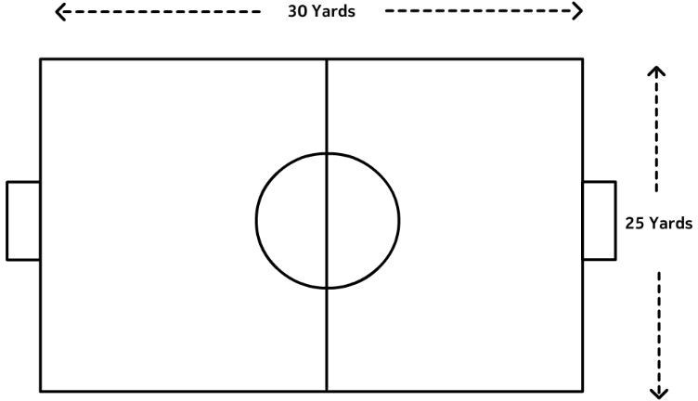

Playing Time: 4 quarters
- U4 - 8 minutes each (32 Minutes Total)
- U6- 12 minutes each (48 Minutes Total)

Number of Players on Field : 4 v. 4
- No Goalkeepers (Coaches, be aware of your positioning)
- Minimum: 3
Ball Size: 3
Field Dimensions: 30 yards x 25 yards
Throw-ins: No
Heading: Not Allowed (per USSF Mandate)
Referees: U4: Volunteer Coaches U6: 1 Referee provided by LOSC

The Field
- Dimensions: The field will be approximately

30 yards long and 25 yards wide, with a center circle with a 6yd radius.
- Goals: Goals will be 4 ft high and 6 ft wide.

The Ball
- A size 3 ball will be provided by the home team.

Number of Players
- Recommended roster size per team is 8.
- Maximum number of players per team on the field at one time is four (4).
- Minimum Number of Players: per team on
the field to start or continue the game is three (3). Coaches should loan players to a team that is short of the minimum in order to allow all children to play and have fun!
- Substitutions can be made on any stoppage
of play such as a kick-in, kickoff, free kick, goal kick, corner kick, or injury stoppage.

Players’ Equipment
- Uniforms: All Players are required to wear the appropriate jerseys.
- The team listed first on the schedule shall be the home team.
- Player must not use equipment or wear anything dangerous to themselves or another player (No jewelry of any kind).
- Shin guards: Players must wear shin guards
covered by long socks.
- Footwear: Soccer cleats are recommended, not required. No shoes with toe cleats (baseball cleats). No metal cleats.

Referees
- Only one coach per team allowed on the field. Coaches must have a background check completed before their first game.
- Both team’s on-field coach-referees should work together to referee the game to ensure all players are safe and enjoying the game

Duration of the Game / Playing Time
- U4: 8 minute quarters; U6: 12 minute quarters
- Half-time must be five (5) minutes.
- Quarter breaks must be two (2) minutes.
- The referees shall allow for time lost through injury (only when a player is replaced) or accident (ball is lost or burst, a dog is on the field, etc.,) but not allow the half to run longer than 30 minutes.
- Playing Time: Each player MUST play a minimum of 50% of the total playing time. Coaches MUST make every effort to balance playing time between all players at the game.

Starting The Game
- The game begins with a kickoff in the center circle, by the Home team, to start the first half. The Away team will kick off to start the second half. The opposing team must line up outside the center circle on their own half of the field.
- The player taking the kickoff cannot touch the ball a second time before it has been touched by another player. For a violation of this rule, the kick shall be retaken.
- A goal may NOT be scored directly from the kickoff. It must touch another player before going into the goal. If the ball is kicked directly into a goal from a kickoff award a goal kick.
- A kickoff occurs at the beginning of each quarter and after each goal.

Ball In and Out of Play
- The ball is out of play when it has entirely crossed over the touchline.
- Coaches should try to let play flow to avoid constant stopping, and not call out of bounds in a strict manner.
- Play restarts with a throw-in for the other team. Opposing players must be 5 yards away.
- U4 may dribble the ball in bounds instead of kick-ins.

Off-Side
• There is no offside

Method of Scoring
- The ball must completely travel over the goal line, inside of the goal.

Fouls and Misconduct
- All fouls should result in a direct free kick with the opponents 6 yards away.
- Encourage young players to only use their feet.
- The coach/parent must explain ALL infractions to the offending player.
- While slide tackles are legal when done correctly, coaches are not to instruct or encourage players to play on the ground. Players should be encouraged to stay on their feet to tackle the ball from an opponent.

Free Kick
- All fouls will result in a direct free kick.
- All opponents must be 6 yards away until the ball is in play.

Penalty Kick
- No penalty kicks for this age group

Goal Kick
- Goal kicks are taken from the team’s goal line. U4 may dribble the ball in bounds instead of kick-ins.
- Opponents must be no closer than the midfield line until the ball is in play.
- A goal may NOT be scored directly from a goal kick.

Corner Kick
- When the ball has completely crossed the goal line, except through the goal, either on the ground or in the air, and was last played or touched by a player of the defending team, it shall be kicked into play from the corner of the field on the same side of the goal on which it went across the goal line by the attacking team.
- Opponents must be 6 yards away from the ball.

