
U4-U6 Recreational Rules
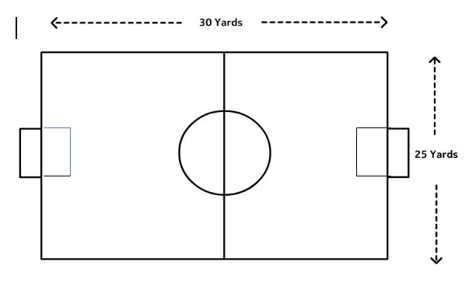

Playing Time: 4 quarters
- U4 - 8 minutes each (32 Minutes Total)
- U6- 12 minutes each (48 Minutes Total)
Ball Size: 3

Number of Players on Field: 4 v 4, minimum 3
- No Goalkeepers (Coaches, be aware of your positioning
Field Dimensions: 30 yards x 25 yards (approx.)
Heading: Not Allowed (per USSF Mandate)
Referees: U4: Volunteer Coaches U6: 1 Referee provided by LOSC

The Field
- Dimensions: The field dimensions are

30 yards long and 25 yards wide, with a center circle with a 6yd radius.
- Goals: Goals will be 4 ft high and 6 ft wide.

Number of Players
- Recommended roster size per team is 8.
- Maximum number of players per team on the field at one time is four (4).
- Minimum Number of Players: per team on
the field to start or continue the game is three (3). U4: open league roster. U6: teams should play down players if a team is short of the minimum in order to play. Forfeit.
- Substitutions can be made on any stoppage
of play such as a kick-in, kickoff, free kick, goal kick, corner kick, or injury stoppage.

Players’ Equipment
- Uniforms: All Players are required to wear the appropriate jerseys.
- The team listed first on the schedule shall be the home team.
- Player must not use equipment or wear anything dangerous to themselves or another player (No jewelry of any kind).
- Shin guards: Players must wear shin guards
covered by long socks.
- Footwear: Soccer cleats are recommended, not required. No shoes with toe cleats (baseball cleats). No metal cleats.

Referees
- U4- Only one coach per team allowed on the field. Both team’s on-field coach should work together to referee the game to ensure all players are safe and enjoying the game
- U6- No coaches allowed on the field during the game. Coaches are to stay on the sideline during the running clock, unless an injury occurs.
- U6 has one (1) referee. Referees will control the flow of the game (spotting the ball in correct places for throw ins, corners, goal kicks, and free kicks).
- Coaches must have a background check completed before their first game.

Duration of the Game / Playing Time
- U4: 8 minute quarters; U6:12 minute quarters
- Half-time must be five (5) minutes.
- Quarter breaks must be two (2) minutes.
- The referees shall allow for time lost through injury (only when a player is replaced) or accident (ball is lost or burst, a dog is on the field, etc.,) but not allow the half to run longer than 30 minutes.
- Playing Time: Each player MUST play a minimum of 50% of the total playing time. Coaches MUST make every effort to balance playing time between all players at the game.

Starting The Game
- The game begins with a kickoff in the center circle, by the Home team, to start the first quarter. The Away team will kick off to start the second quarter. The opposing team must line up outside the center circle on their own half of the field.
- The player taking the kickoff cannot touch the ball a second time before it has been touched by another player. For a violation of this rule, the kick shall be retaken.
- A goal may NOT be scored directly from the kickoff. It must touch another player before going into the goal. If the ball is kicked directly into a goal from a kickoff award a goal kick.

Ball In and Out of Play
- The ball is out of play when it has entirely crossed over the touchline.
- Coaches should try to let play flow to avoid constant stopping, and not call out of bounds in a strict manner.
- U4 & U6 play restarts with a throw-in for the other team. Opposing players must be 6 yards away.

- Off-Side
• There is no offsides in U4 and U6.

Method of Scoring
- The ball must completely travel over the goal line, inside of the goal.
- We do not keep score in U4.

Fouls and Misconduct
- All fouls should result in an INDIRECT free kick with the opponents 6 yards away.
- Encourage young players to only use their feet.
- The coach/referee in U4 must explain all infractions to the offending player.
- Slide tackling is not allowed in U4 or U6.
- Pushing/shoving is not allowed.

Free Kick
- All fouls will result in an INDIRECT free kick.
- All opponents must be 6 yards away until the ball is in play.
- No penalty kicks for the U4 or U6 age group
Goal Box
- A goal box will be put in place for all goal kicks and designated no player area.
- There are no goalies in U4 or U6. A single player is allowed to play directly in front of the goal box, but no offensive or defensive players are allowed inside the box. A ball stopped inside the goal box will result in a goal kick.

Goal Kick
- Goal kicks are taken from the team’s goal line.
- Opponents must be no closer than the midfield line until the ball is in play.
- A goal may NOT be scored directly from a goal kick.

Corner Kick
- When the ball has completely crossed the goal line, except through the goal, either on the ground or in the air, and was last played or touched by a player of the defending team, it shall be kicked into play from the corner of the field on the same side of the goal on which it went across the goal line by the attacking team.
- Opponents must be 6 yards away from the ball.

